**Name : Chandana Ramesh Galgali Roll Number : 16010422234 Batch : B-4**

**Tutorial - 6**

**______________________________________________________________________________**

**Code:**

**<!-- HTML FILE -->**

**<!DOCTYPE html>**

**<html lang="en">**

**<head>**

**<meta charset="UTF-8">**

**<meta name="viewport" content="width=device-width, initial-scale=1.0">**

**<title>Perfume Emporium</title>**

**<link rel="stylesheet" href="styles.css">**

**</head>**

**<body>**

**<header>**

**<h1>Perfume Emporium</h1>**

**<nav>**

**<ul>**

**<li><a href="#samepage">Home</a></li>**

**<li><a href="#">Shop</a></li>**

**<li><a href="#">About Us</a></li>**

**<li><a href="#samepage">Contact</a></li>**

**</ul>**

**</nav>**

**</header>**

**<section class="main-section">**

**<h2>Featured Perfumes</h2>**

**<div class="perfume-grid">**

**<div class="perfume">**

**<img src="perfume1.jpg" alt="Perfume 1">**

**<h3>L'Instant Magic</h3>**

**<p>L'Instant Magic by Guerlain is a captivating fragrance that embodies elegance and femininity. It opens with fresh and citrusy notes of bergamot and lemon, leading into a delicate floral heart of jasmine and rose. The base notes of white musk and cedarwood add depth and warmth to this enchanting scent, leaving a trail of magic wherever you go.</p>**

**</div>**

**<div class="perfume">**

**<img src="perfume2.jpg" alt="Perfume 2">**

**<h3>Miss Dior</h3>**

**<p>Miss Dior by Christian Dior is a timeless and iconic fragrance that exudes charm and sophistication. This classic scent features top notes of Italian mandarin and Egyptian jasmine, giving it a fresh and floral opening. The heart of the fragrance is a bouquet of rose and patchouli, creating a romantic and elegant allure. With its musky and woody base notes, Miss Dior leaves a lasting impression, making it the perfect choice for any occasion.</p>**

**</div>**

**</div>**

**</section>**

**<footer>**

**<p>&copy; 2024 Perfume Emporium. All rights reserved.</p>**

**</footer>**

**</body>**

**</html>**

**/* CSS FILE */**

**body {**

**font-family: Arial, sans-serif;**

**margin: 0;**

**padding: 0;**

**}**

**header {**

**background-color: #f0f0f0;**

**padding: 20px;**

**box-shadow: 0 2px 4px rgba(0, 0, 0, 0.1);**

**}**

**header h1 {**

**margin: 0;**

**}**

**nav ul {**

**list-style-type: none;**

**margin: 0;**

**padding: 0;**

**display: flex;**

**justify-content: center;**

**}**

**nav ul li {**

**margin-right: 20px;**

**}**

**nav ul li a {**

**text-decoration: none;**

**color: #333;**

**}**

**nav ul li a:hover {**

**color: #5a3975;**

**}**

**.main-section {**

**padding: 20px;**

**text-align: center;**

**}**

**.perfume-grid {**

**display: grid;**

**grid-template-columns: repeat(auto-fit, minmax(300px, 1fr));**

**gap: 20px;**

**}**

**.perfume {**

**background-color: #919191;**

**border-radius: 15px;**

**box-shadow: 0 2px 4px rgba(0, 0, 0, 0.1);**

**transition: transform 0.3s ease;**

**}**

**.perfume:hover {**

**transform: translateY(-10px);**

**}**

**.perfume img {**

**width: 100%;**

**height: auto;**

**border-radius: 15px;**

**}**

**footer {**

**background-color: #333;**

**color: #fff;**

**text-align: center;**

**padding: 20px;**

**}**

**@media (max-width: 768px) {**

**nav ul {**

**flex-direction: column;**

**align-items: center;**

**}**

**nav ul li {**

**margin-bottom: 10px;**

**}**

**.perfume-grid {**

**grid-template-columns: 1fr;**

**}**

**}**

**______________________________________________________________________________**

**Output:**

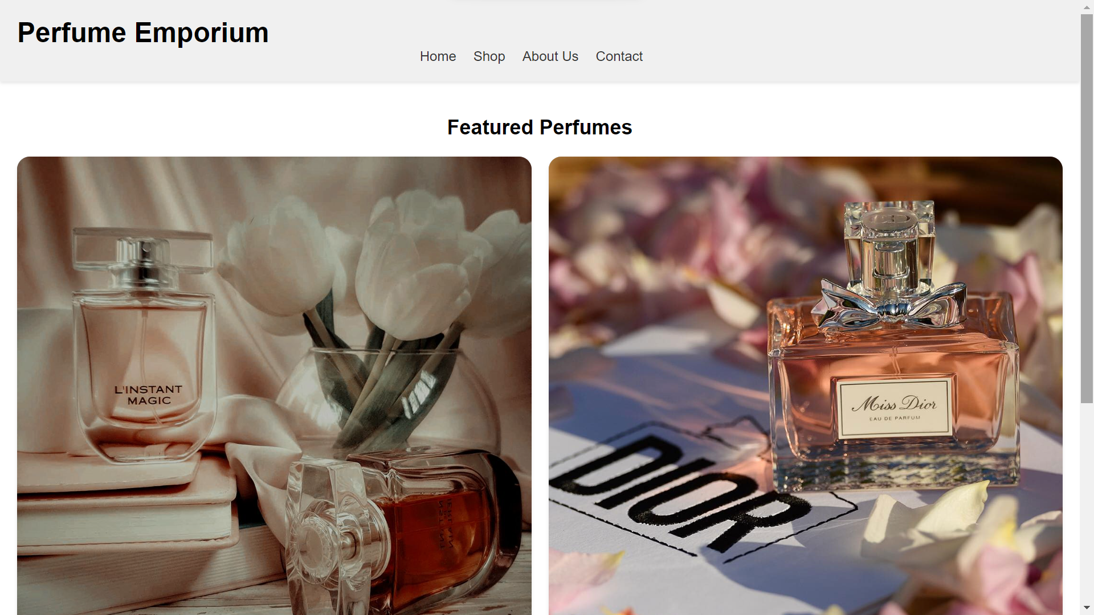

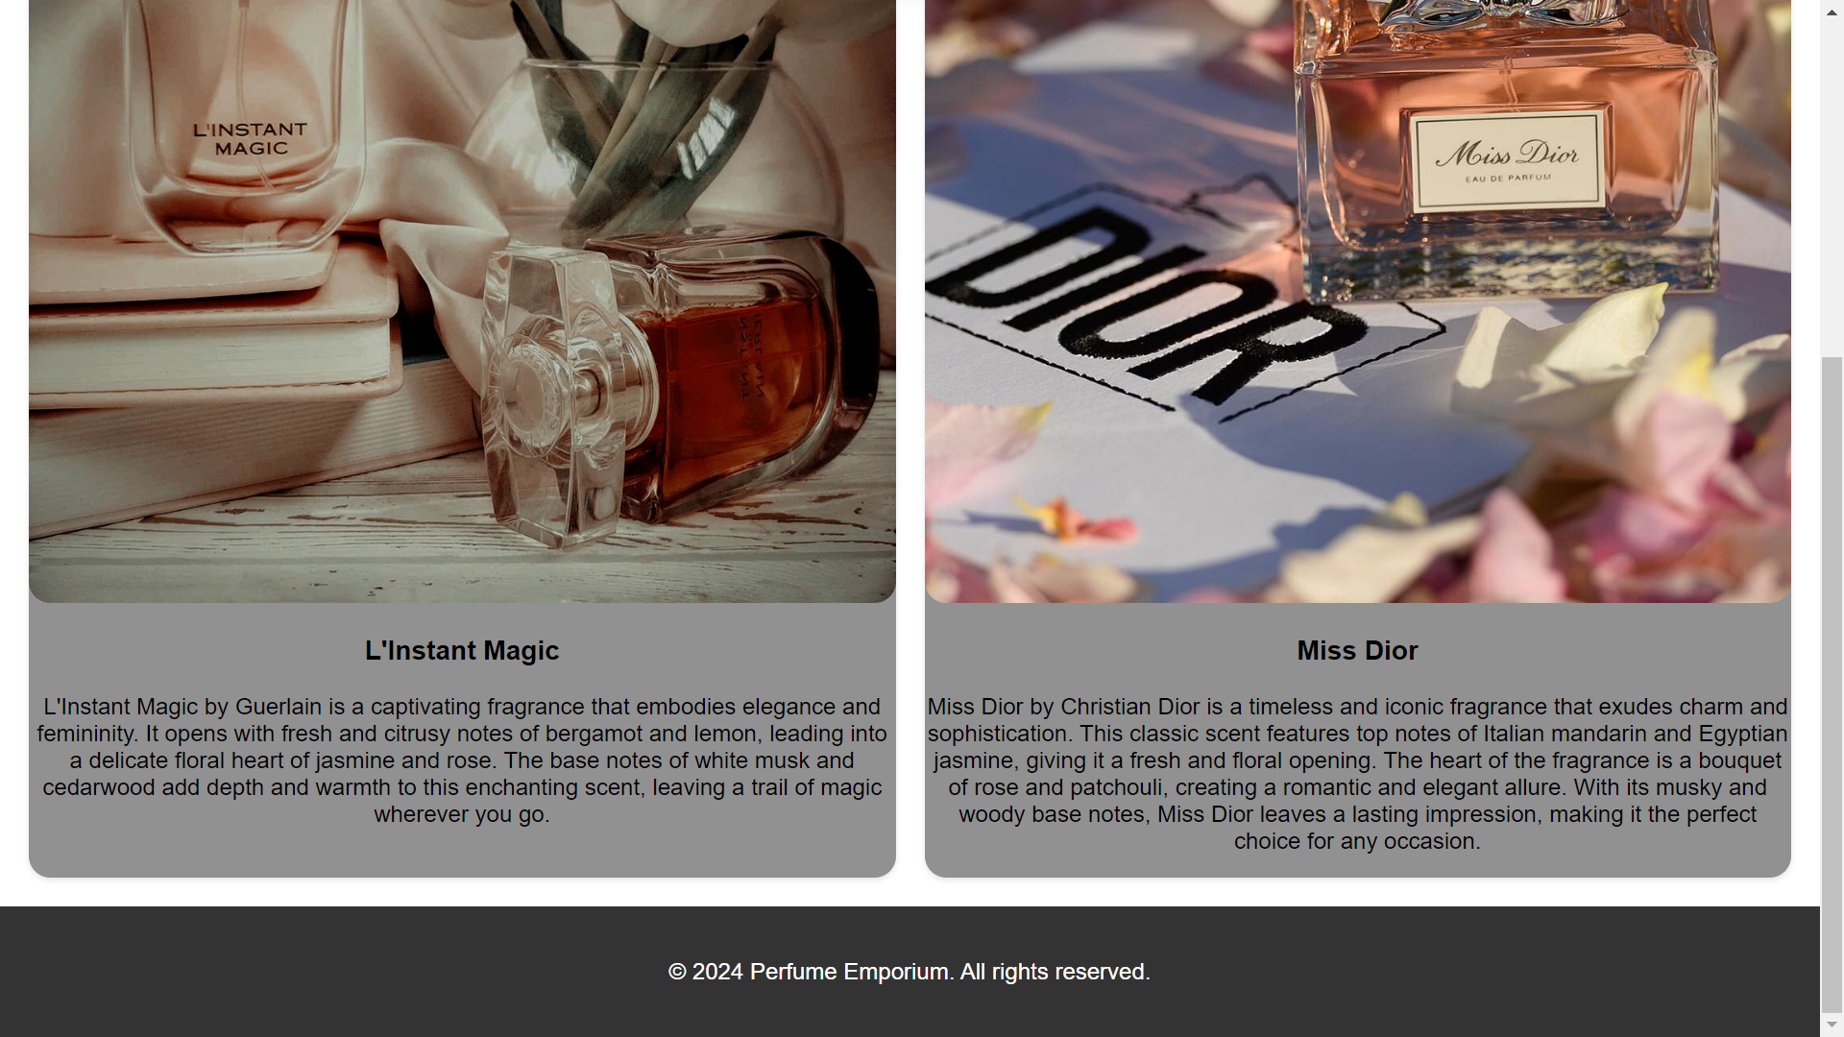

**______________________________________________________________________________**

**Outcomes:** Create Web pages using HTML 5 and CSS.

**______________________________________________________________________________**

**Conclusion: (Conclusion to be based on the outcomes achieved)**

The experiment conclusively demonstrated that the strategic use of Flexbox and Grid, combined with responsive design principles, facilitates the creation of web pages that are visually appealing, flexible, and accessible on a wide range of devices. The successful implementation of these techniques in the "Perfume Emporium" project serves as a practical testament to the efficacy of modern CSS features in achieving responsive and flexible web design goals. This experiment underscores the importance of adopting these approaches in web development to meet the evolving needs of users in a digital landscape characterized by a vast array of devices and screen sizes.

**______________________________________________________________________________**